**Strategy about future**

**Material and Human resource**

The biggest thing that impede the built out of a strong charging station network is high cost of equipment and installation. The main categories of charging station can be listed as; actual charging station hardware; other hardware and materials; electrician and other labor; mobilization; and permitting. You can see the shares of these categories on figures below. [1]

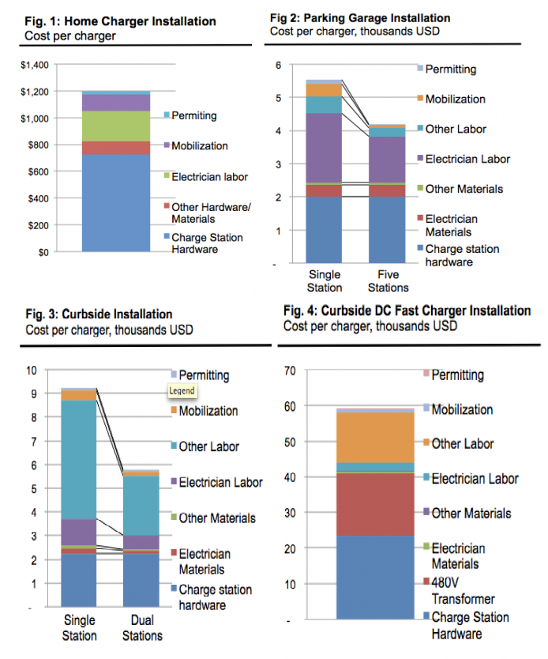

As it is seen charge station hardware cost and labor costs has the biggest shares of charging stations. When the charging station technology become advanced, other labor cost (other than electrician labor) increase. This shows that advancing technology in charging stations requires highly skilled human resources. Hardware costs problem can solve innovative advancements in the future. Charging stations should be easy to setup and use in the future. But it is also solved by understanding the laws and regulations because usage of high level electricity related products covered by laws.

**EVs battery**

**Charging speed**

**Home battery**

**Maintenance**

**Payment system and Price**

**Blockchain technology**

**cost of charging station**

[**http://blog.rmi.org/blog_2014_04_29_pulling_back_the_veil_on_ev_charging_station_costs**](http://blog.rmi.org/blog_2014_04_29_pulling_back_the_veil_on_ev_charging_station_costs)

1. [**http://blog.rmi.org/blog_2014_04_29_pulling_back_the_veil_on_ev_charging_station_costs**](http://blog.rmi.org/blog_2014_04_29_pulling_back_the_veil_on_ev_charging_station_costs)